EXPERIMENT 15: - Create a Snapshot of a VM and Test it by loading the Previous Version/Cloned VM

Step 1: - Install VM Ware PlayStation

Step 2: - Create new virtual machine

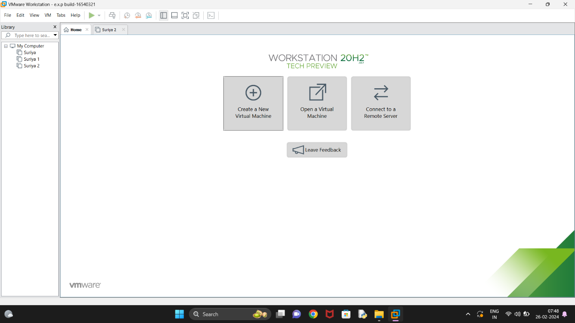

Step 3: - Choose Typical option and click Next

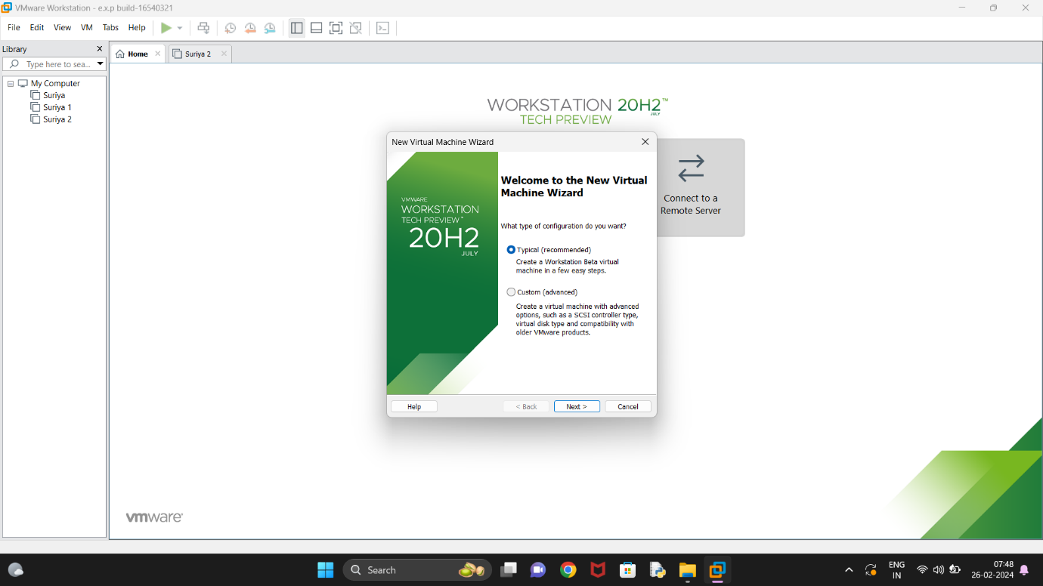

Step 4: - Click on the third option at guest os screen

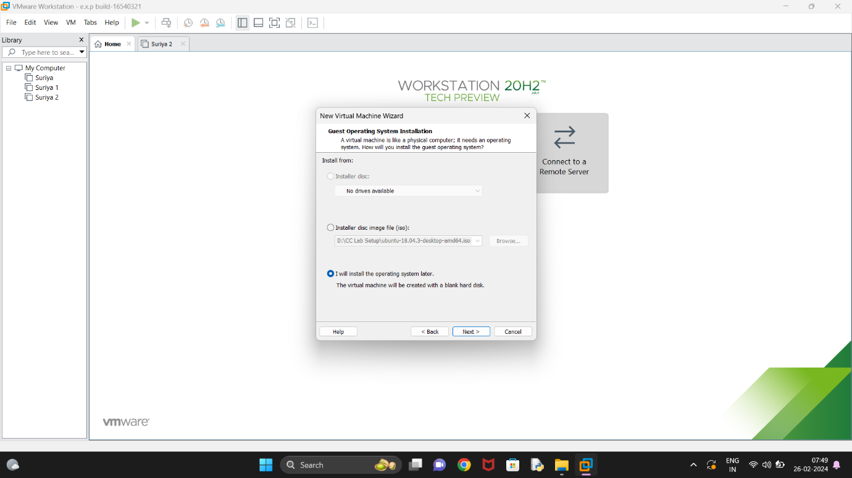

Step 5: - Choose the required os and click next

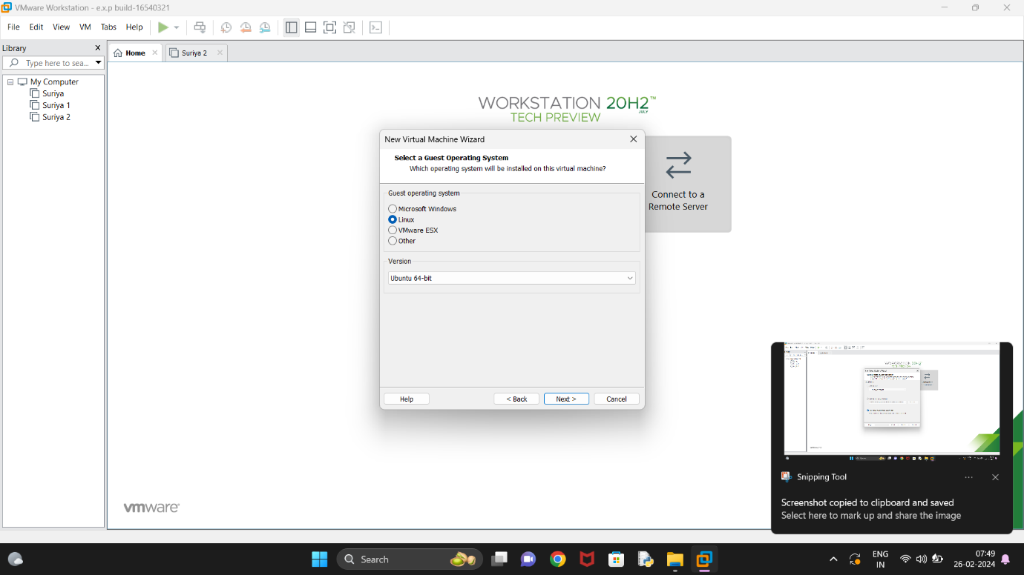

Step 6: - Enter the name of the virtual machine

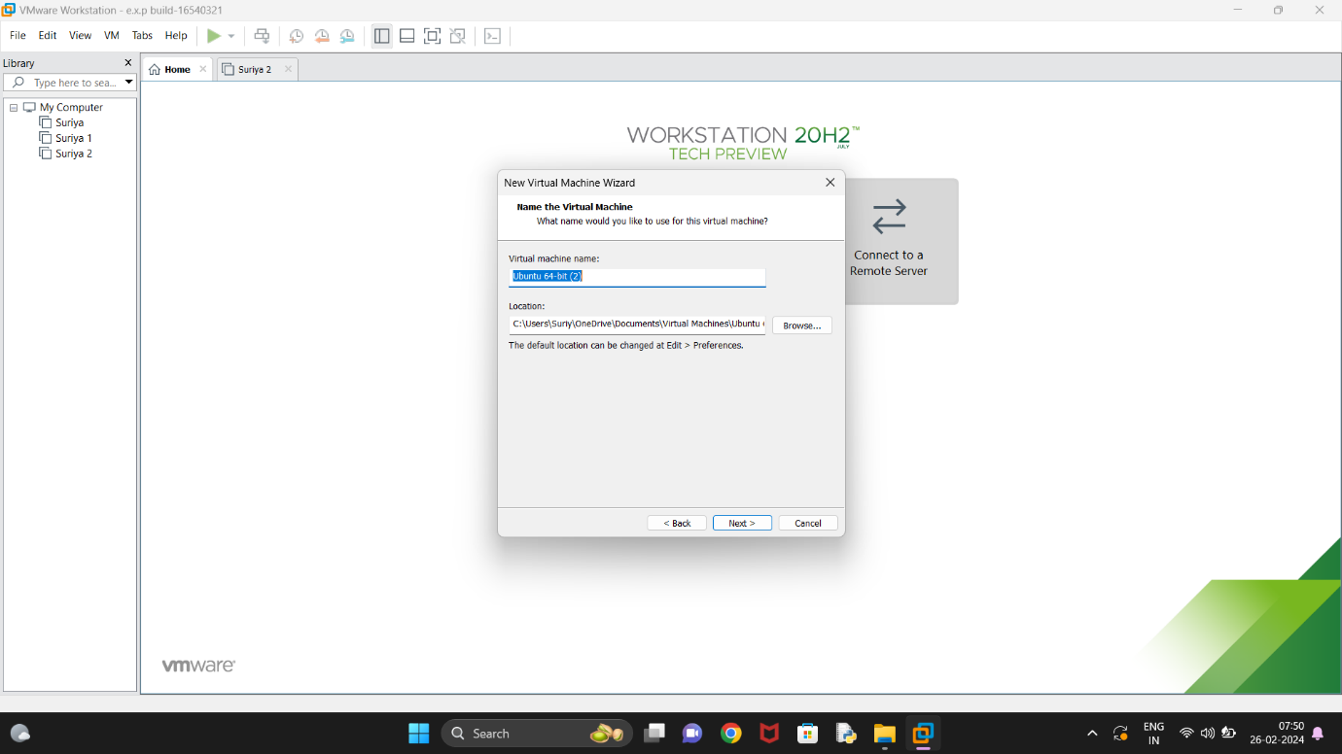

Step 7: - Edit the disk space and click next

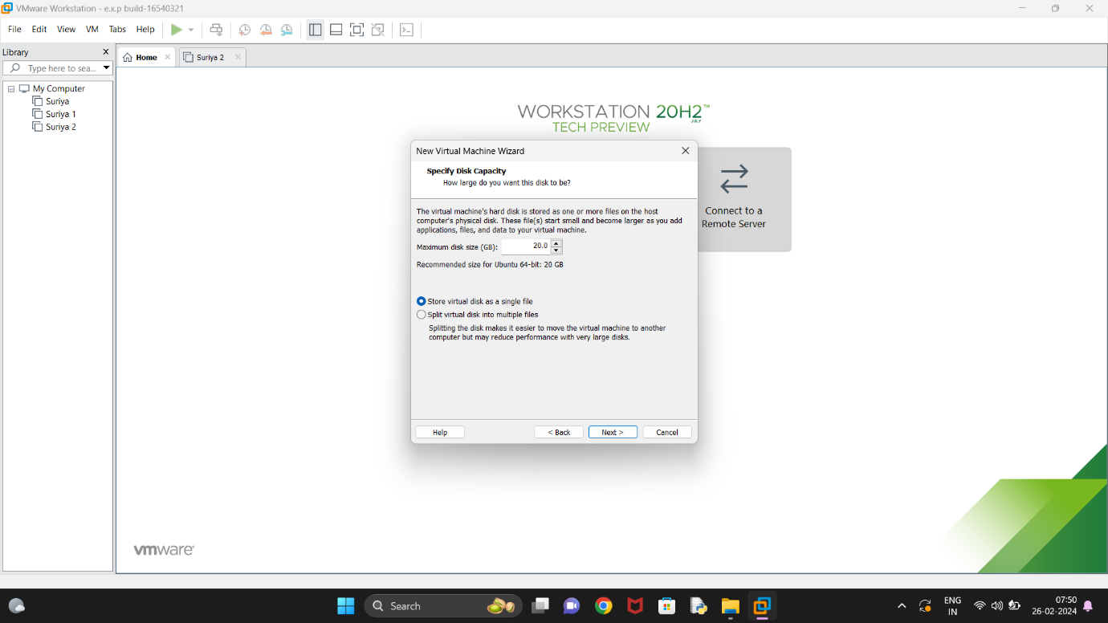

Step 8: - Check the summary and click next

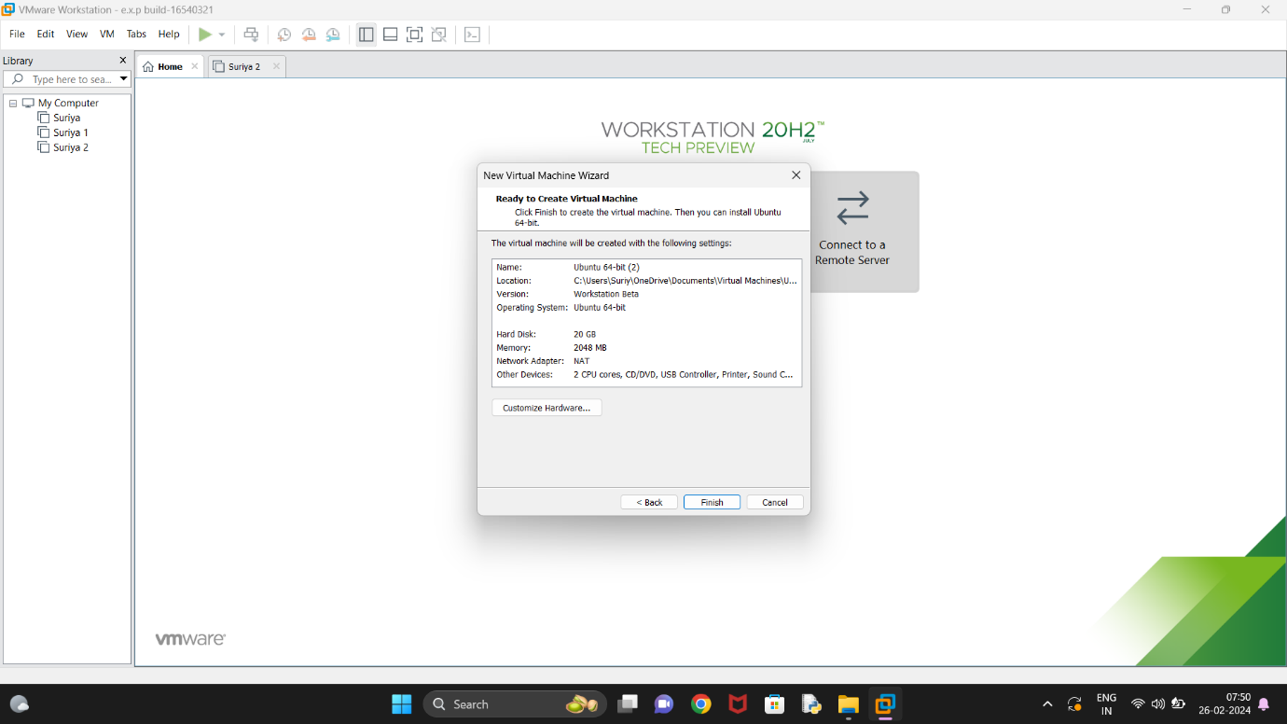

Step 9: - Go to VM, manage, and click on clone

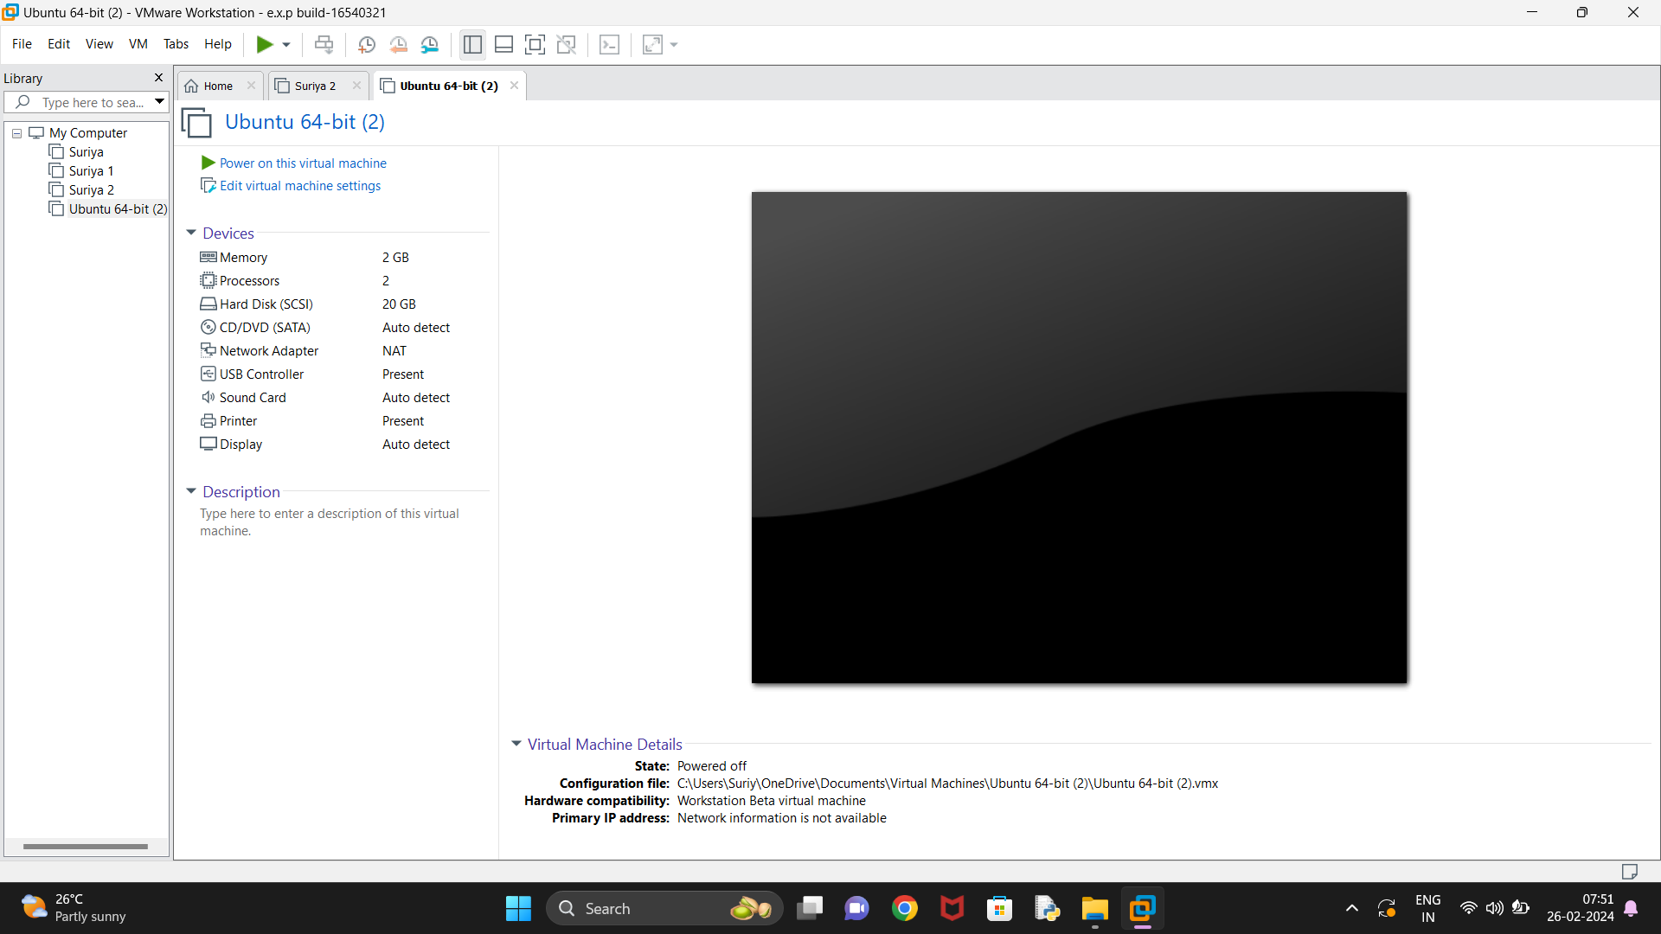

Step 10: - Click yes on clone wizard

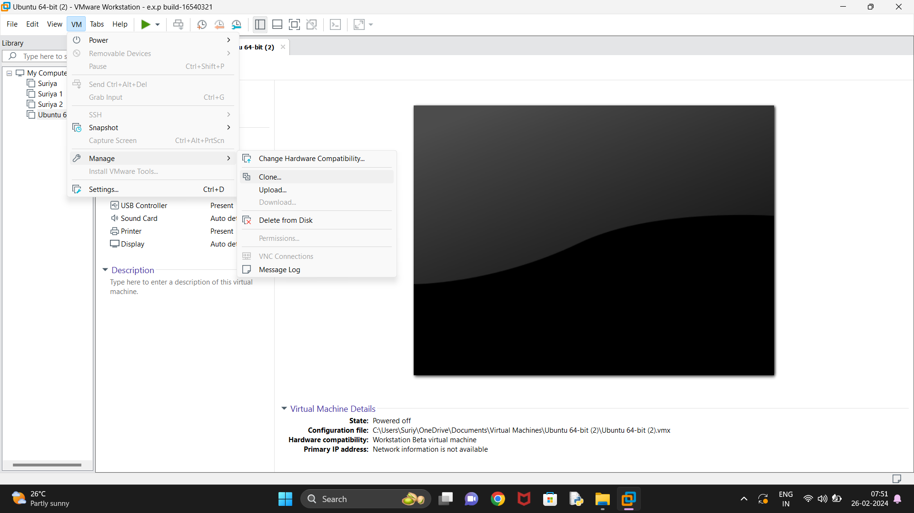

Step 11: - Click on full clone and click next

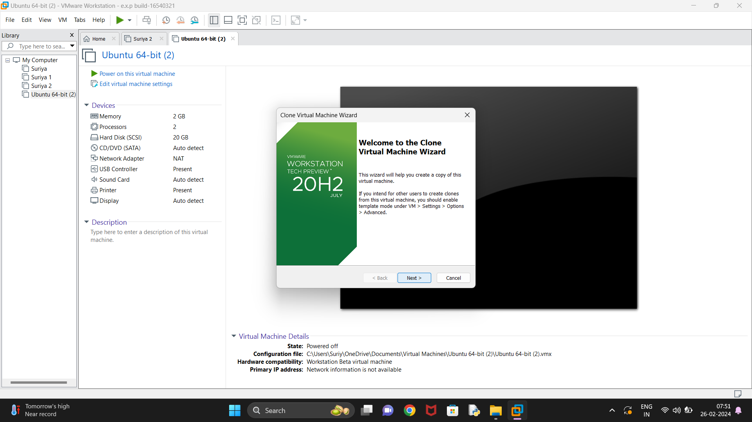

Step 12: - Enter name of clone virtual machine and click finish

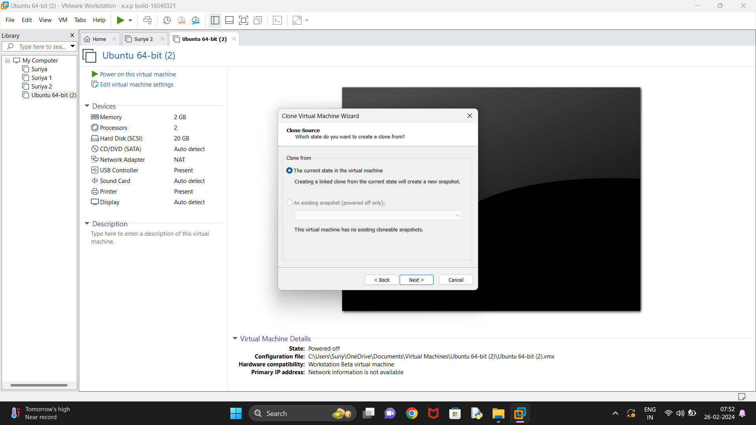

Step 13: - Click on close

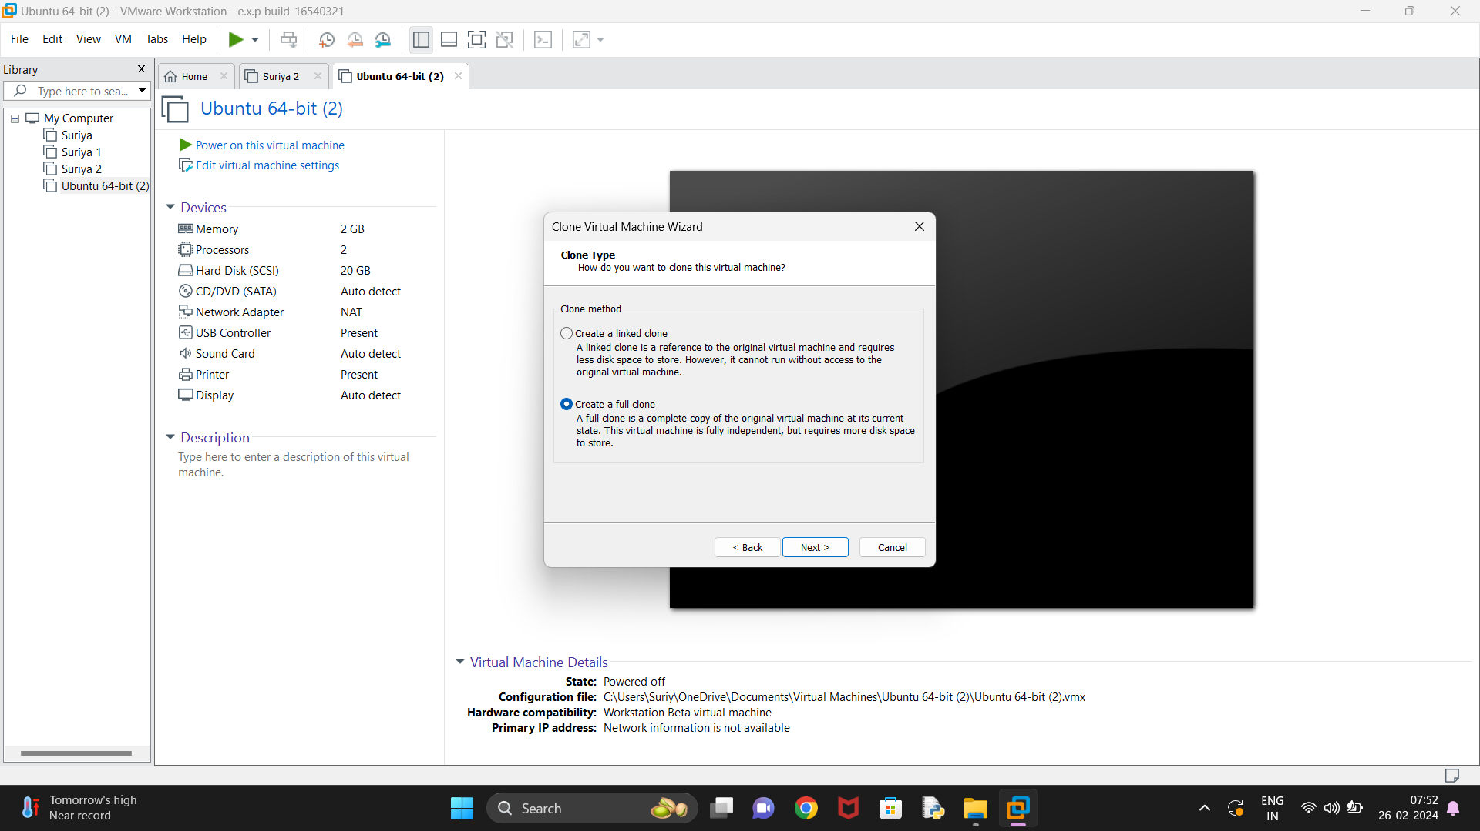

Step 14: - Clone machine was successfully created.

